|  |  |  |
| --- | --- | --- |
| **LAB221 Assignment** | **Type:** | **Short Assignment** |
| **Code:** | **J2.S.P0127** |
| **LOC:** | **25** |
| **Slot(s):** | **1** |

**Title** Position box color

**Background Context**

KeyboardEvent objects describe a user interaction with the keyboard. Each event describes a key; the event type (keydown, keypress, or keyup) identifies what kind of activity was performed. They usually use in web, and game.

**Program Specifications**

Design a program that allows users move a box color using arrow key

***Function details:***

User using arrow key to change position of box color

***Expectation of User interface:***

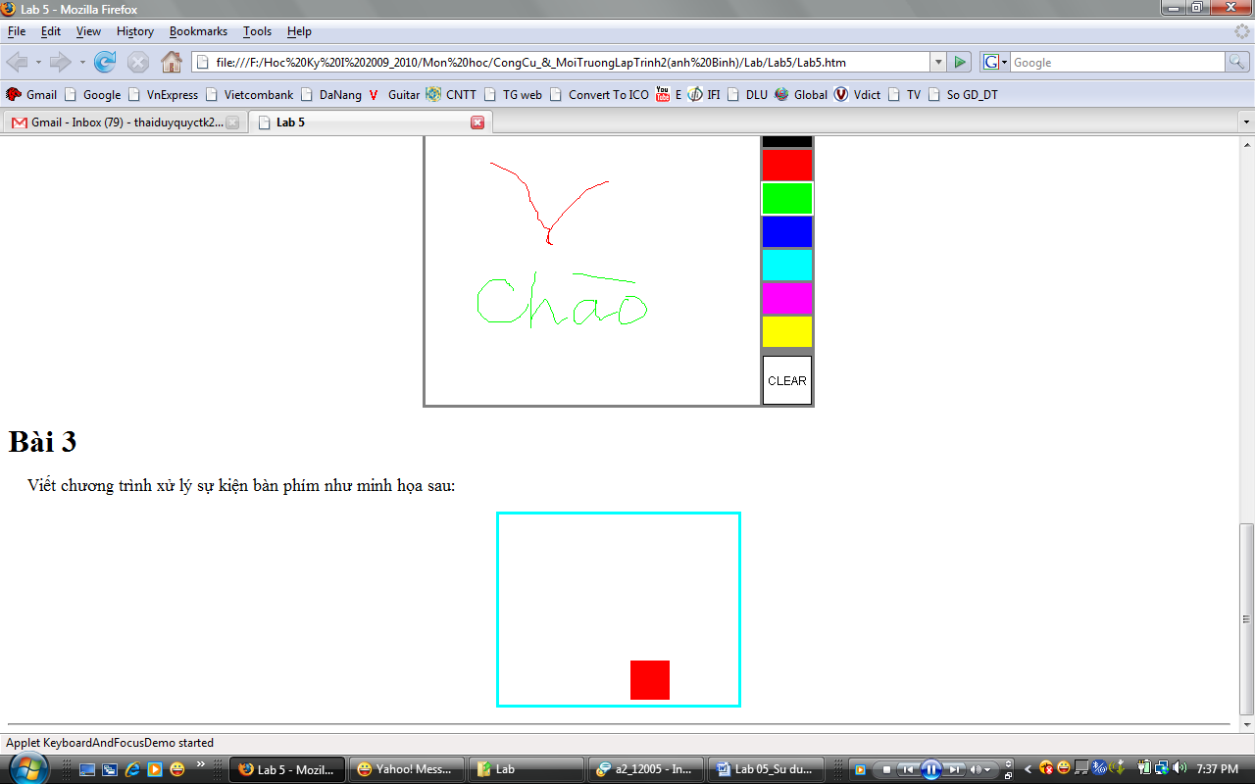

**Guidelines**